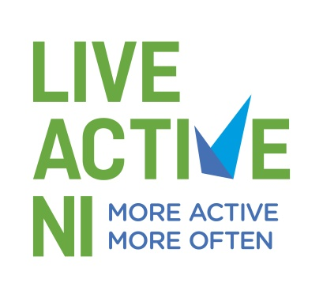
PERSONNEL SPECIFICATION

Job Title: Active Recreation Officer – Derry City & Strabane District Council

Reporting to: Live Active NI Manager

 | Essential | Desirable
Educational, Professional Qualifications and Previous Experience (all experience should be demonstrable) | * A degree or 3rd level qualification which can be demonstrated is relevant to the post.  *Two years full time (or part time equivalent) experience of sports development, sports coaching or community development.  *Two years full time (or part time equivalent) experience of working with people with disabilities and other underrepresented groups.  *Two years full time (or part time equivalent) experience in planning, organising and delivering active recreation sessions and opportunities.  *Experience in the effective use of websites and social media channels.  *Experience of organising events and seminars. | **Sports related degree or 3rd level qualification.  **Experience of working with partnership organisations either in a voluntary or professional capacity.  **Demonstrable experience of delivering training courses.
Knowledge and Understanding | Knowledge and understanding of the barriers to participation in sport and active recreation experienced by people with disabilities and other underrepresented groups.
Skills & Abilities | Competent in the use of Microsoft software packages.  A high level of written and oral communication and presentation skills.  The ability to use own initiative, organise own work, work within budget constraints and achieve agreed targets and objectives within set timescales.  Excellent inter-personal skills and ability to work as part of a team.
Circumstances | *Ability to work evenings and weekends as and when required.  *Access to form of transport that will permit the post holder to meet the needs of the post in full.  *Available and willing to undertake training necessary for the post.

Note to all applicants:

*Only those applicants who clearly demonstrate how their qualifications, knowledge, experience and skills meet the essential criteria will go forward to the next stage in the recruitment and selection process.

**The desirable criteria may be used for short listing if required. All other essential and desirable criteria will be assessed by selection test and/or interview.

